|  |
| --- |
| **National University of Computer and Emerging Sciences** |
| **Lab Manual 4**  “Nested Queries” |
|  |
| **Database Systems Lab** |
| **Spring 2024** |

Department of Computer Science

FAST-NU, Lahore, Pakistan

Contents

2. Objective 2

3. Pre-requisites 2

4. Nested Queries 3

4.1.1. A subquery (inner query) is a SQL select query nested inside a another select query (outer query) 3

4.1.2. A subquery can be nested inside: 3

4.1.3. There are two types of subqueries 3

4.1.4. Scalar Vs Non-scalar 3

Non-Correlated Query: 4

4.1.5. Non-Correlated Subqueries in SELECT clause 4

4.1.6. Non-Correlated Subqueries in From Clause 4

4.1.7. Non-Correlated Subqueries in Where Clause 5

Correlated queries 5

4.1.8. Correlated Subquery in Select Clause 5

4.1.9. Correlated Subquery in Where Clause 6

4.1.10. Correlated Subquery in Having Clause 6

# Objective

* The purpose of this manual is to get started with nested queries. This lab will cover all the topics we have covered before. Starting from simple Select-From-Where, Joins, Order by, Aggregate functions & Group by, all of these will be used in combination with the nested queries.

# Pre-requisites

* Lab manual 3 & 4 which includes:
  + Select-From-Where clause
  + Joins and all its types
  + Order By clause
  + Aggregate functions, Group By and Having

Task Distribution

|  |  |
| --- | --- |
| Total Time | 170 Minutes |
| Nested Queries | 30 Minutes |
| Exercise | 120 Minutes |
| Evaluation | Last 20 Minutes |

# Nested Queries

For this in-lab manual, use the **InLab5TryThisSchema.sql** script to create database and practice the queries given below.

### A subquery (inner query) is a SQL select query nested inside a another select query (outer query)

A subquery may occur in:

* SELECT clause of outer query
* FROM clause of outer query
* WHERE clause of outer query (most commonly used)

### A subquery can be nested inside:

* SELECT statement
* INSERT statement
* UPDATE statement
* DELETE statement
* Another subquery.

### There are two types of subqueries

* Correlated subqueries: where we use some attribute of outer query in inner query, result of inner query will then change according to the attribute of outer query.
* Non-correlated subqueries: where no attribute of outer query is used in inner query, in this case inner query always return same value.

### Scalar Vs Non-scalar

A select query can return a scalar value or a table. Scalar value means one column and one row

Example: result of the following query is scalar

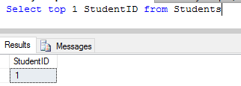

A select query can also return non-scalar value, with more than one column and/or more than one row

Example:

Select StudentID from Students

Will give non-scalar result.

If you are writing a sub query in Select Clause, the inner query should be Scalar

If you are writiing a subquey in From Clause, inner query can be scalar or non-Scalar

If you are writing a subquery in Where Clause, inner query can be scalar or non-Scalar depending on conditon.

## Non-Correlated Query:

### Non-Correlated Subqueries in SELECT clause

SELECT <List of columns of T>

(select ColumnName from <TableName>)

FROM <tablename> AS T

WHERE <condition>

**inner query should be scalar

TRY IT: Non-correlated nested query in Select is not very useful

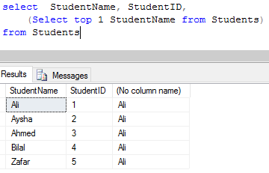

### Non-Correlated Subqueries in From Clause

SELECT <List of columns of T ( result of inner query)>

FROM (select ColumnName from <TableName>) as T WHERE <condition>

**inner query can be scalar of non-scalar

***always give alias to inner query in from clause

TRY THIS

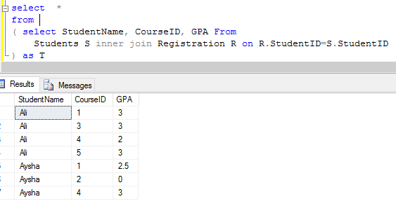

### Non-Correlated Subqueries in Where Clause

SELECT <List of columns of T >

FROM TableName as T

WHERE <condition> (select ColumnName from <TableName>)

TRY THIS

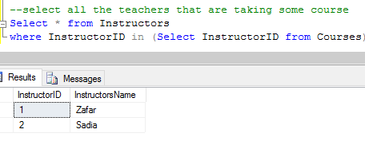

## Correlated queries

When inner query is correlated with outer query, then the inner query is executed for each row of outer query.

### Correlated Subquery in Select Clause

TRY THIS

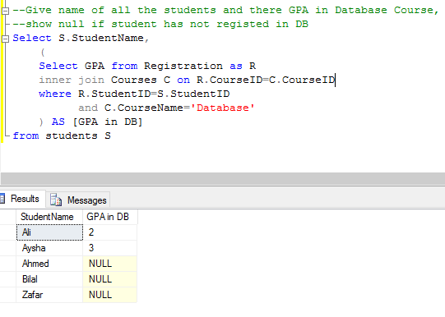

This inner query will get the grade of each row of outer query.

### Correlated Subquery in Where Clause

TRY THIS

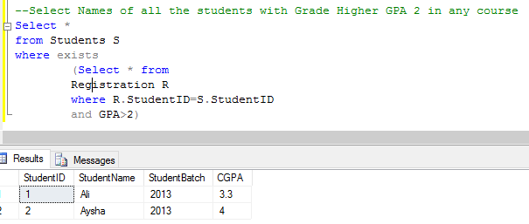

** WHAT DOES THE EXIST CLAUSE DO?

### Correlated Subquery in Having Clause

You can also use subquery in having clause (correlated on non-correlated)

TRY THIS

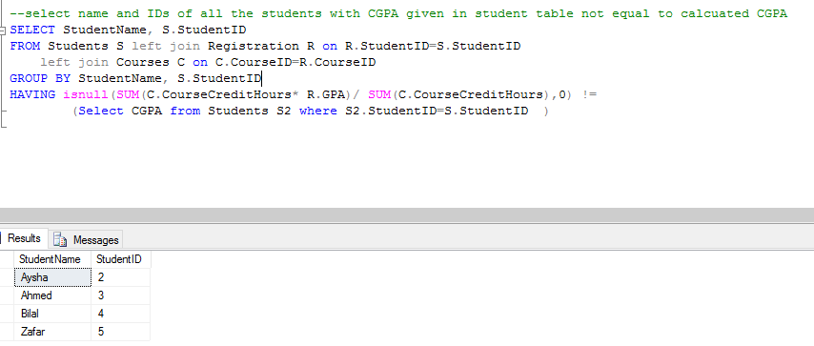

Modify the query given above to, Show name, IDs, Calcuated CGPA and CGPA given in Student table of all the students with CGPA given in student table lesser to calcuated CGPA